ENVELOPE – Written neatly in BLACK PEN - please notice the comma between the city and state
Return Address Delivery Address Stamp
First and last name
# Street Name (apt if applicable)
City, State ZIP code
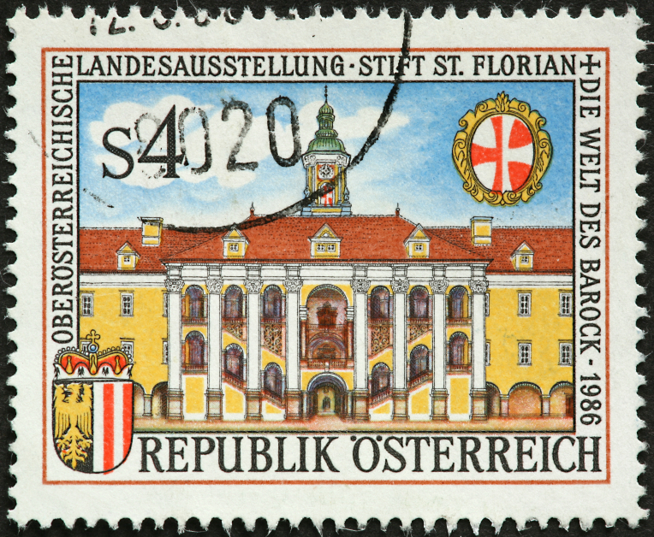

Dept or Person’s name (if applicable)
Company Name (if applicable)
# Street Name (Write P.O. Box here if no street address)
City, State ZIP code

SPECIAL NOTE: if you do not want to use your own address, you can write the following in the Return Address area – ( you will also include this info on the typed letter – be sure to follow the format)

Your first and last name
C/O Trisha Gonzalez
Manhattan Beach Middle School
1501 N Redondo Ave
Manhattan Beach, CA 90266

Before you receive your envelope, you need to find the address and practice here!

Return Address Delivery Address

